
Using the General Assembly Website

Finding your state legislator:
- How to find your state legislator
  - Go to the General Assembly website (link) and click “FIND MY LEGISLATOR”



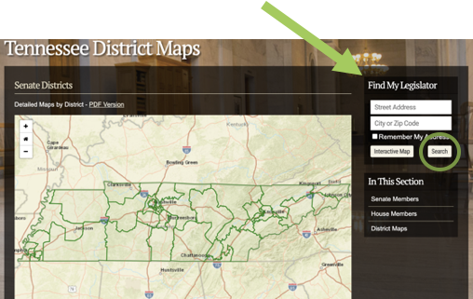

- Type your address and city or zip code into the website page

- Clicking the legislator’s name link to their bio page, clicking on their email address allows you to email them directly
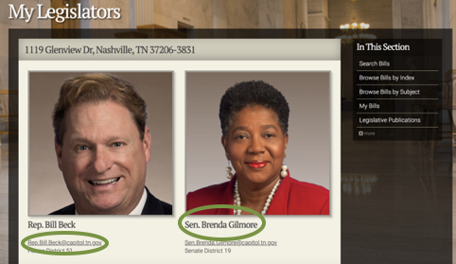

How to find legislation

- Browse bills by index or use a keyword or bill number to search under the “LEGISLATION” tab
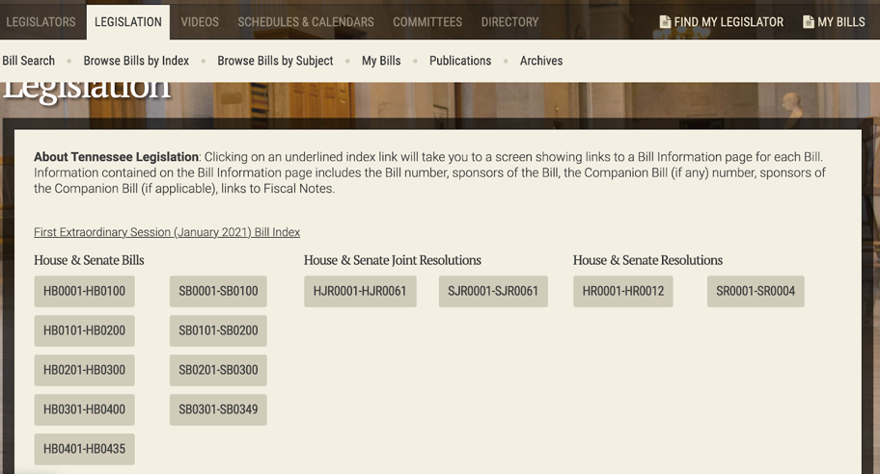

- The picture below is a bill page
  - You can find the bill number and summary on the left side of the page
  - You can also click on the names of the sponsors of the bill and see what other bills they are working on (along with their legislative/personal profile)
  - Bill History shows the cross-filed bill number (SB0225) and actions taken on the bill
  - Videos can be useful to understand the discussion and debate about the bill and bill subject occurring in the legislature
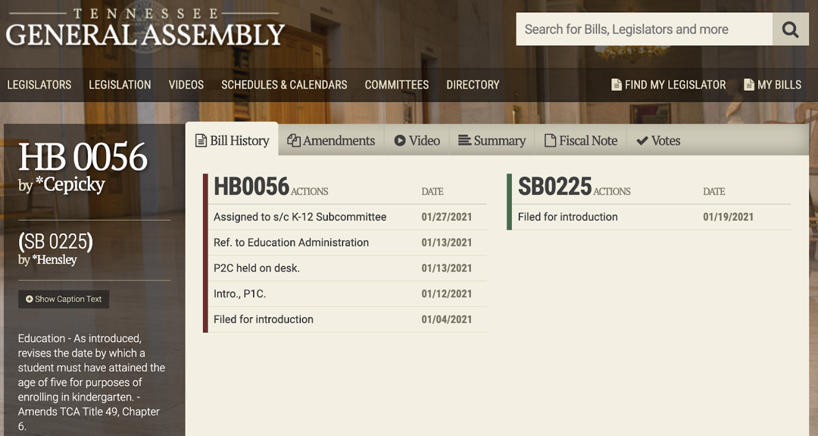

Bill Tracking
- Sign up for bill tracking using the “MY BILLS” function
- You have to register (name, email and password) and create a “list”, then you can start saving bills so that you can keep an eye on them

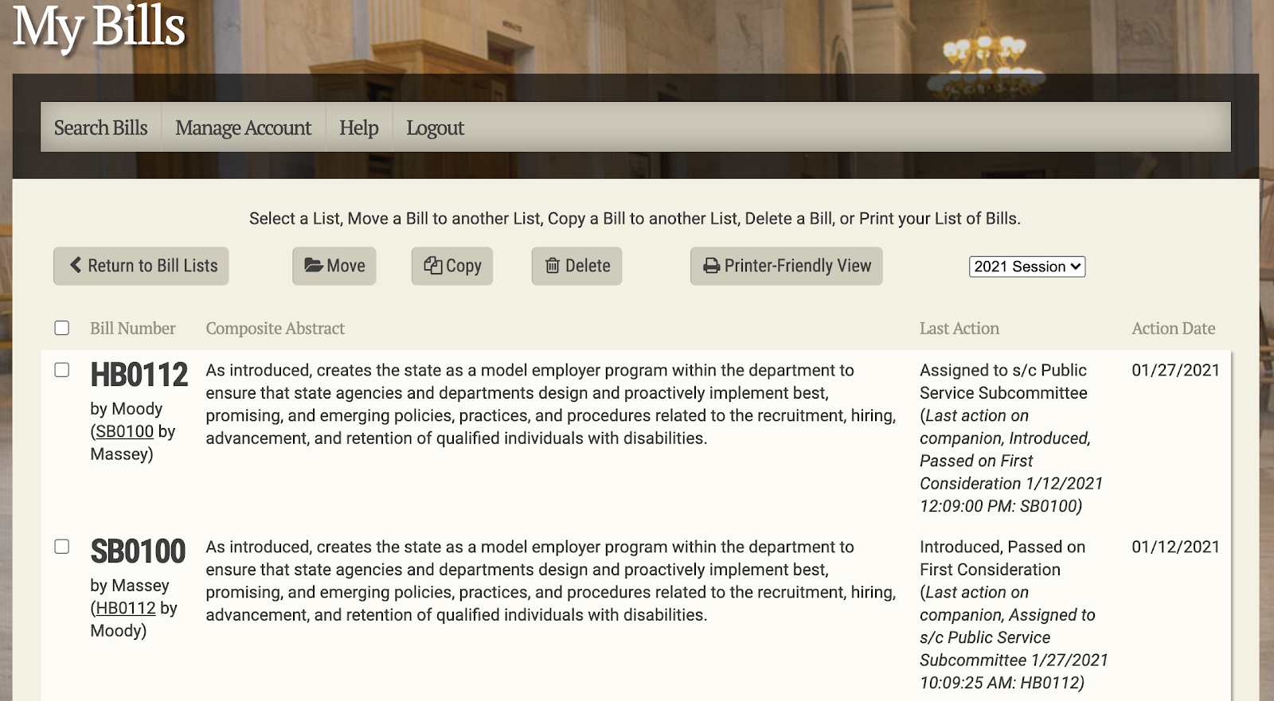

- Saved bills look like the above picture – their bill numbers and sponsors are on the left, a summary of the bill is in the center and last actions and action dates are to the right.
  - Last actions allows you to also see what’s coming next – for example, HB0113 will be in the Public Service Subcommittee next

