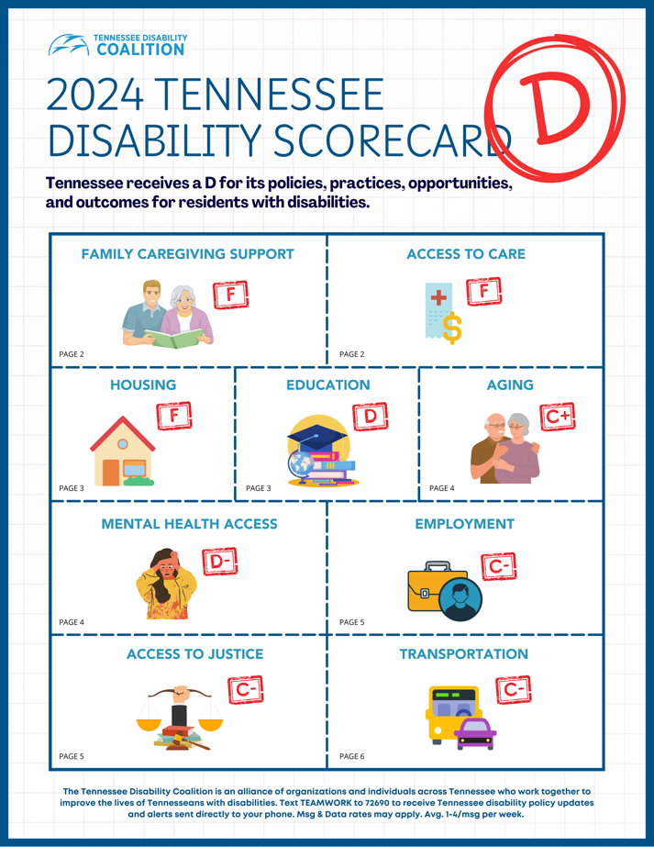
Using the 2024 TN Disability Scorecard with Legislators & State Leaders

The 2024 Disability Scorecard gives a letter grade to areas of life like transportation for Tennesseans with disabilities, to show what life is like and what challenges we face in our state. The state of Tennessee has a poor grade, a D, because the policies, opportunities and outcomes for residents with disabilities are poor.

You can use this Scorecard to help you speak to life in Tennessee in the areas that matter the most, and give suggestions of what our legislators and state leaders can do to make this state better.

The Scorecard matters, as a third of our state, or about 1.7 million of us, experience some form of disability.

The needs of people with disabilities are not special. The Scorecard categories, including transportation and housing, reflect the basic needs of everyone in Tennessee.

Look through the Scorecard categories, choose one or two categories you have a personal experience with, and share your experience with your legislator or state leader! You can also choose the “homework” assignments for those categories and ask that your legislator consider making those changes to improve life for people with disabilities in Tennessee.


While the “D” grade for Tennessee isn’t what any of us would like, we know that working on the homework together with our legislators and state leaders, we can improve the state’s score and in doing so, we can improve the lives of all Tennesseans.

Here’s an example of how to talk about the Scorecard area “Family Caregiving Support” with your legislator or state leader

When our loved ones need care, the role of caregiver often falls to family members who live in the same home. This can be a full-time job and many caregivers find it impossible to work a paying job, especially outside the home, in addition. Caregiving is also a tough job, and many folks lack an opportunity for respite.

AARP ranked TN 51st out of 51 states in the support it provides to family caregivers. This data can be helpful to share along with your personal story about what life is like as a family caregiver for you or your loved one.

Then, you can ask your legislator or state leader to take action. For example:


Working together, we can make Family Caregiving Support in TN a lot better by:

1. Establish a statewide Paid Family Caregiving policy that ensures caregivers receive compensation for providing services that the state fails to provide themselves.

2. Stabilize the caregiver network by increasing pay to providers, including direct support professionals (DSPs).

3. Make a rule that TennCare has to report about the amount of services that people with disabilities are actually receiving, not just enrolled in. This could help the state understand whether the network of service providers is meeting the needs of people with disabilities.

